Unit 1: Uniform Motion Name_______________________________
Lab 2 Date__________________Period________

Multiple Representations of Motion

The Ultrasonic Motion Detector

Do the following for each of the situations below:
a. Move, relative to the motion detector, so that you produce a position vs. time graph which closely approximates the graph shown.
b. In the space provided, describe how you must move in order to produce the position vs. time graph shown in the space to the right of the velocity vs. time graph. Be sure to include each of the following in your description: starting position, direction moved, type of motion and relative speed.
c. On the velocity vs. time axes, sketch the velocity vs. time graph which corresponds to the position vs. time graph shown.
- In the space provided, sketch the motion map that corresponds to the motion described in the position vs. time graph (Include one dot per second),
Note: For each position vs. time graph, assume that the position axis is scaled from zero to 3.0 meters and the time axis is scaled from 0 to 10 seconds.
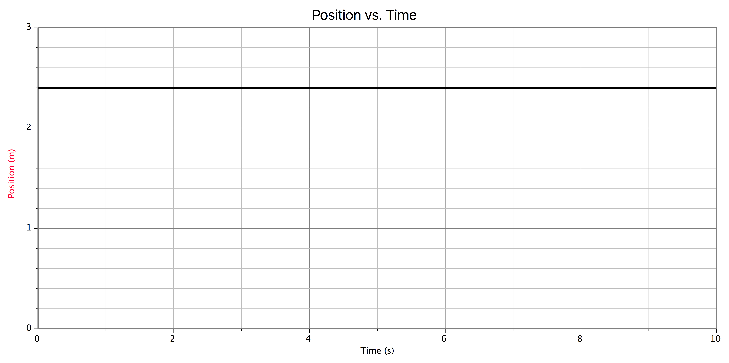
1. Written Description of Motion:

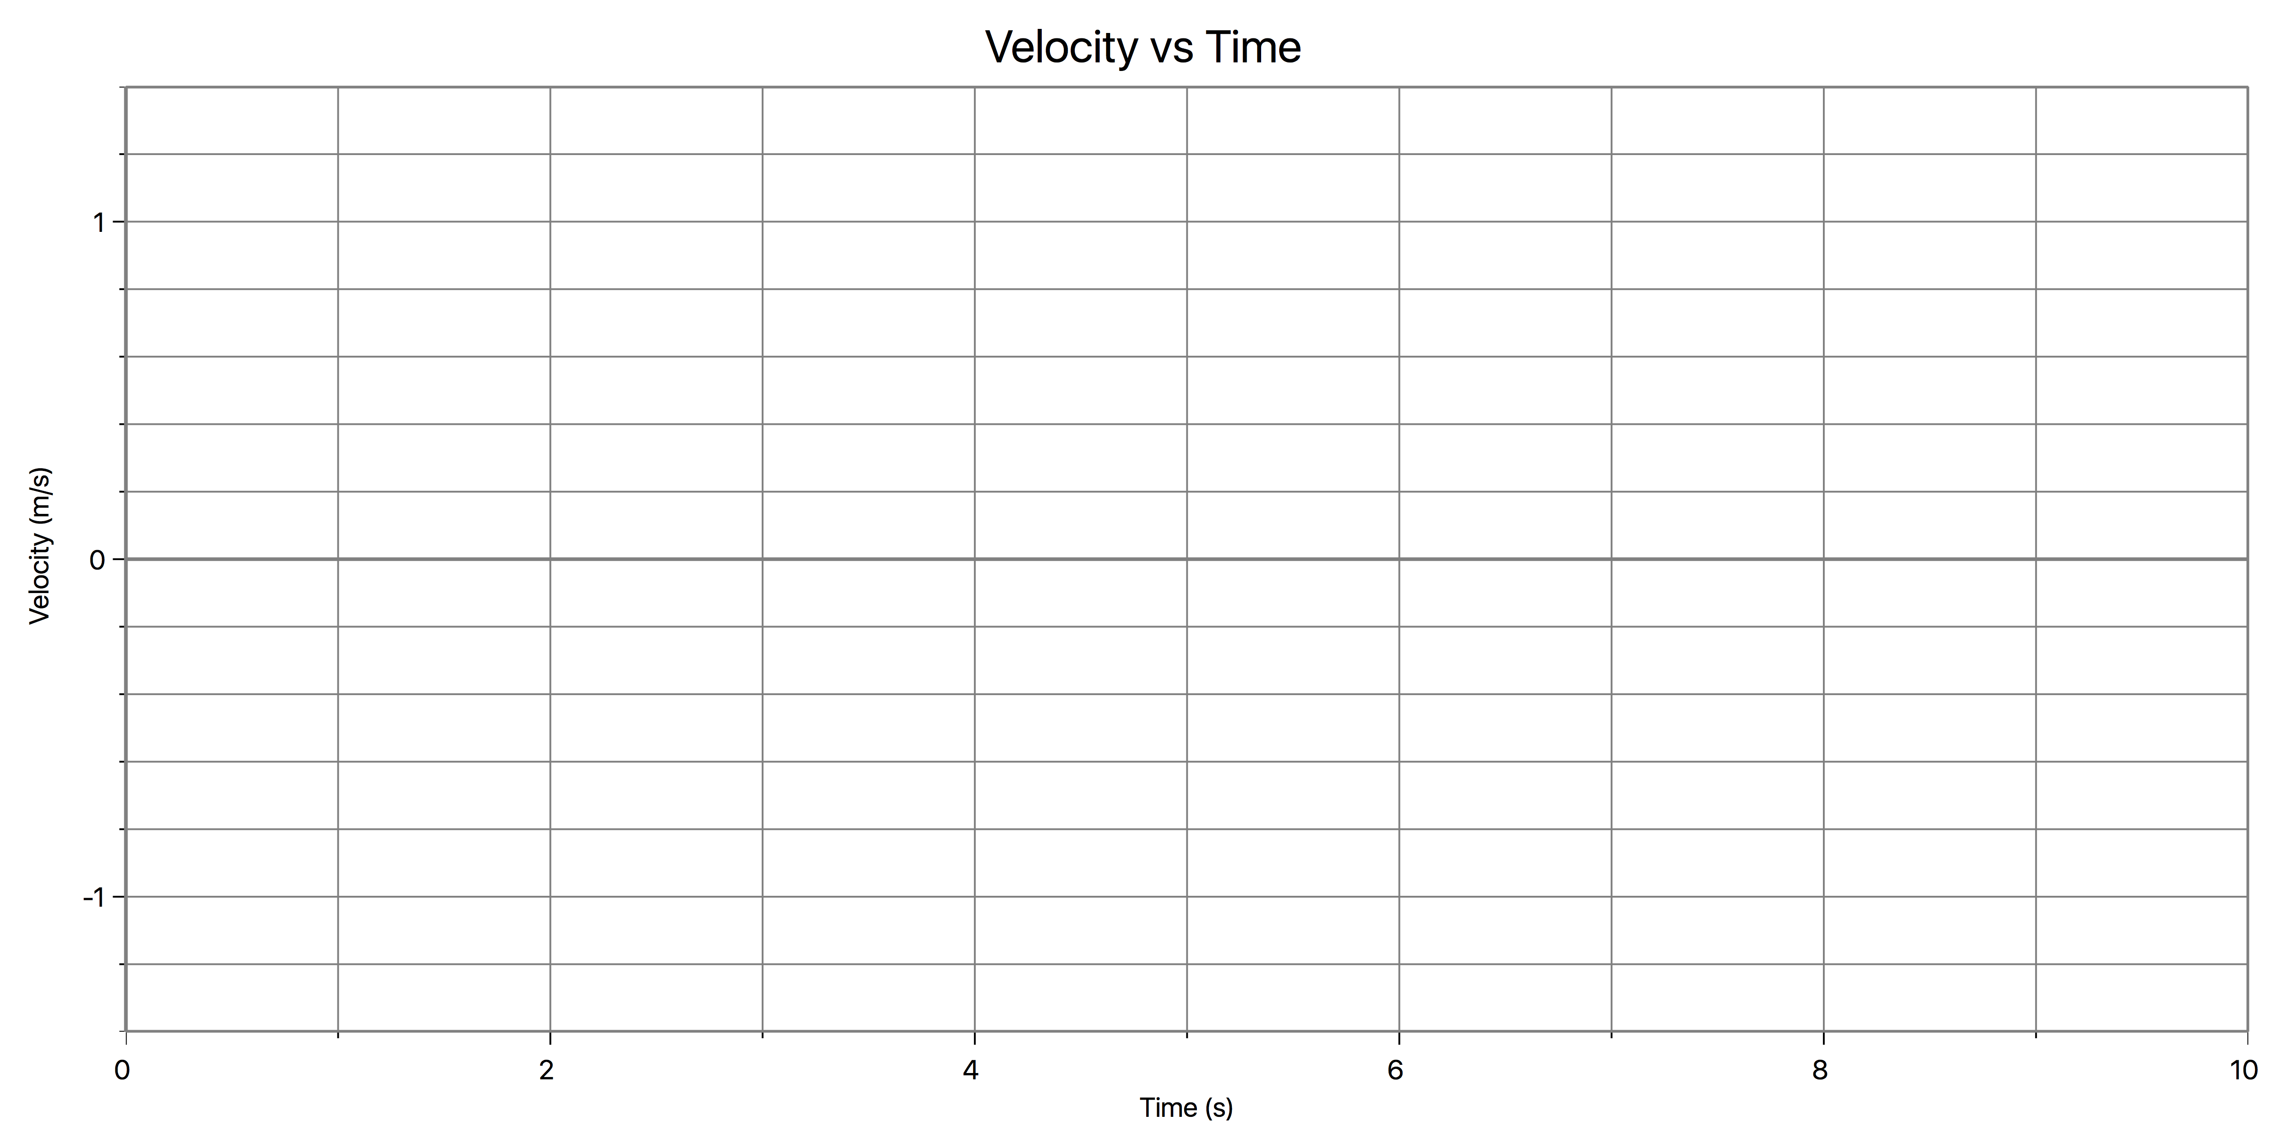

Motion Map:

0
+

2. Written Description of Motion:
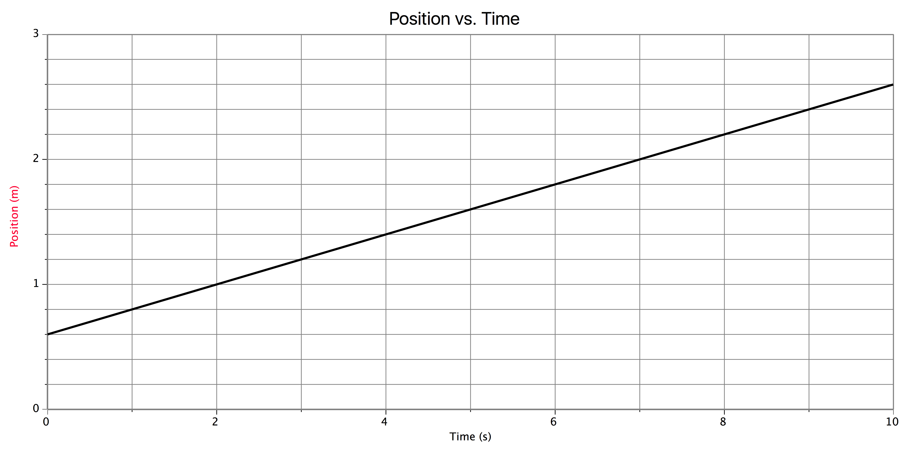

Motion Map:
0
+

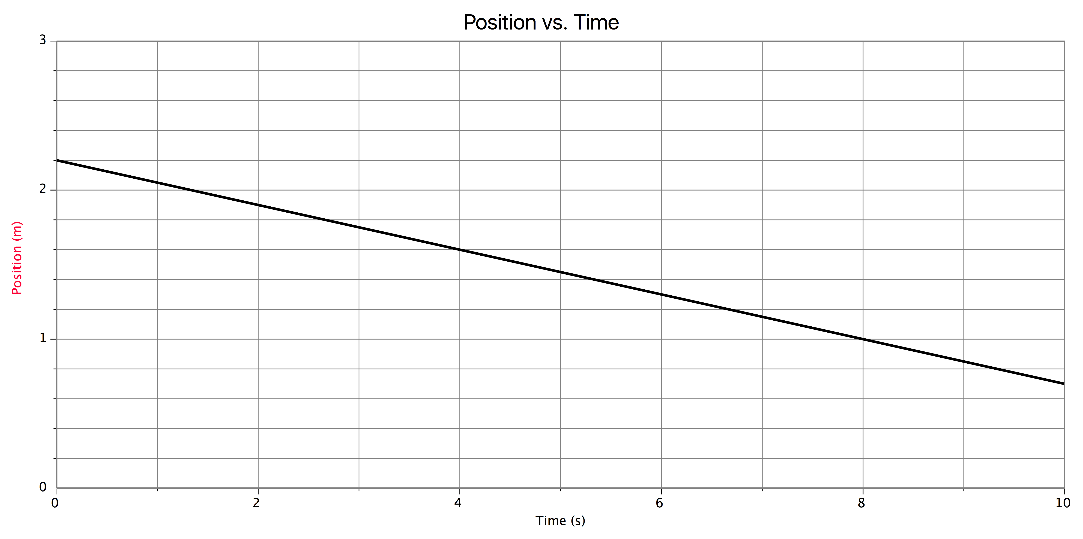

3. Written Description of Motion:

Motion Map:

0
+

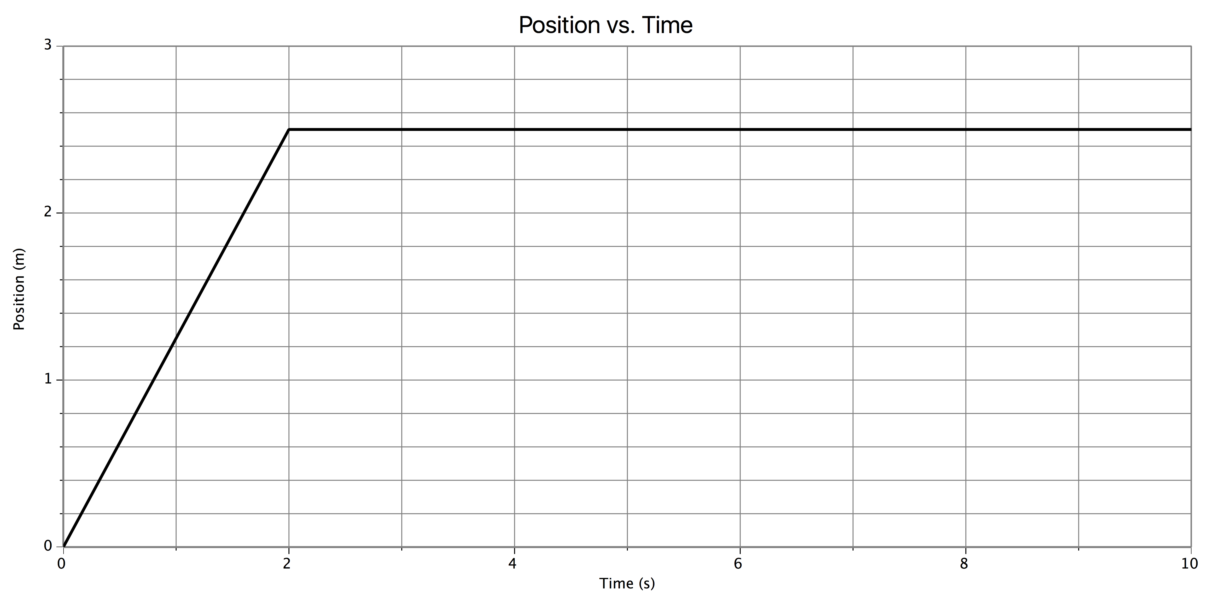
4. Written Description of Motion:

Motion Map:

0
+

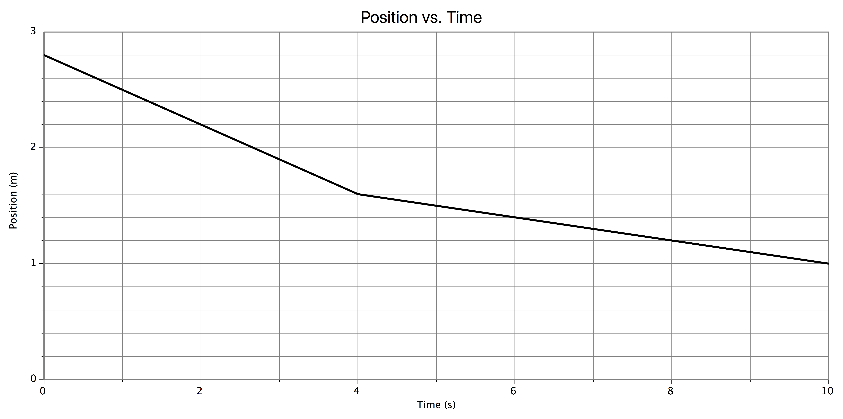
5. Written Description of Motion:

Motion Map:

0
+

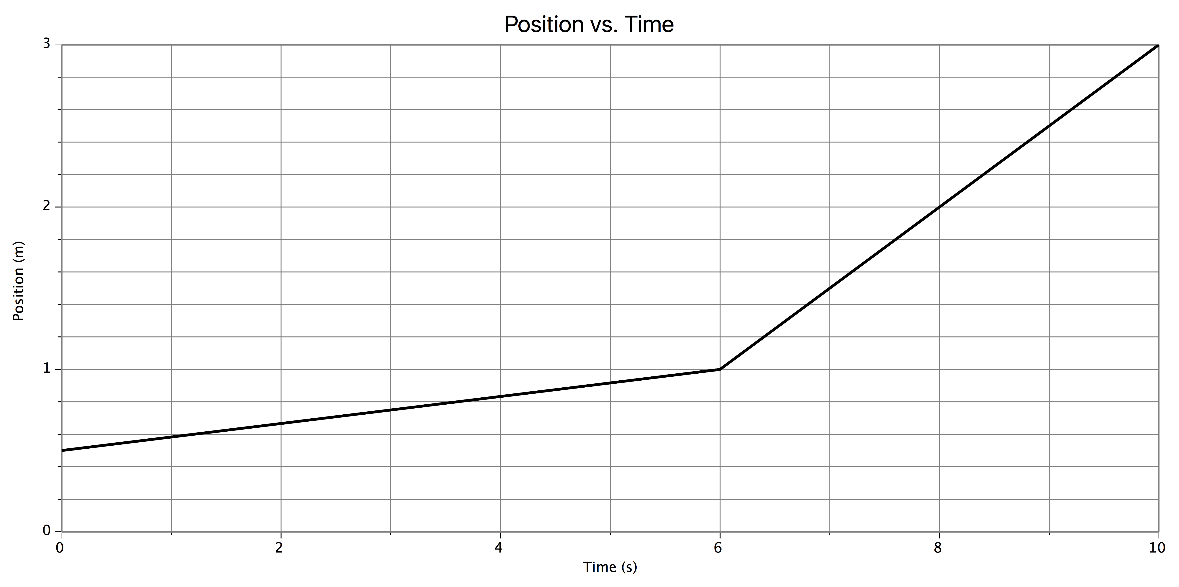
6. Written Description of Motion:

Motion Map:

0
+

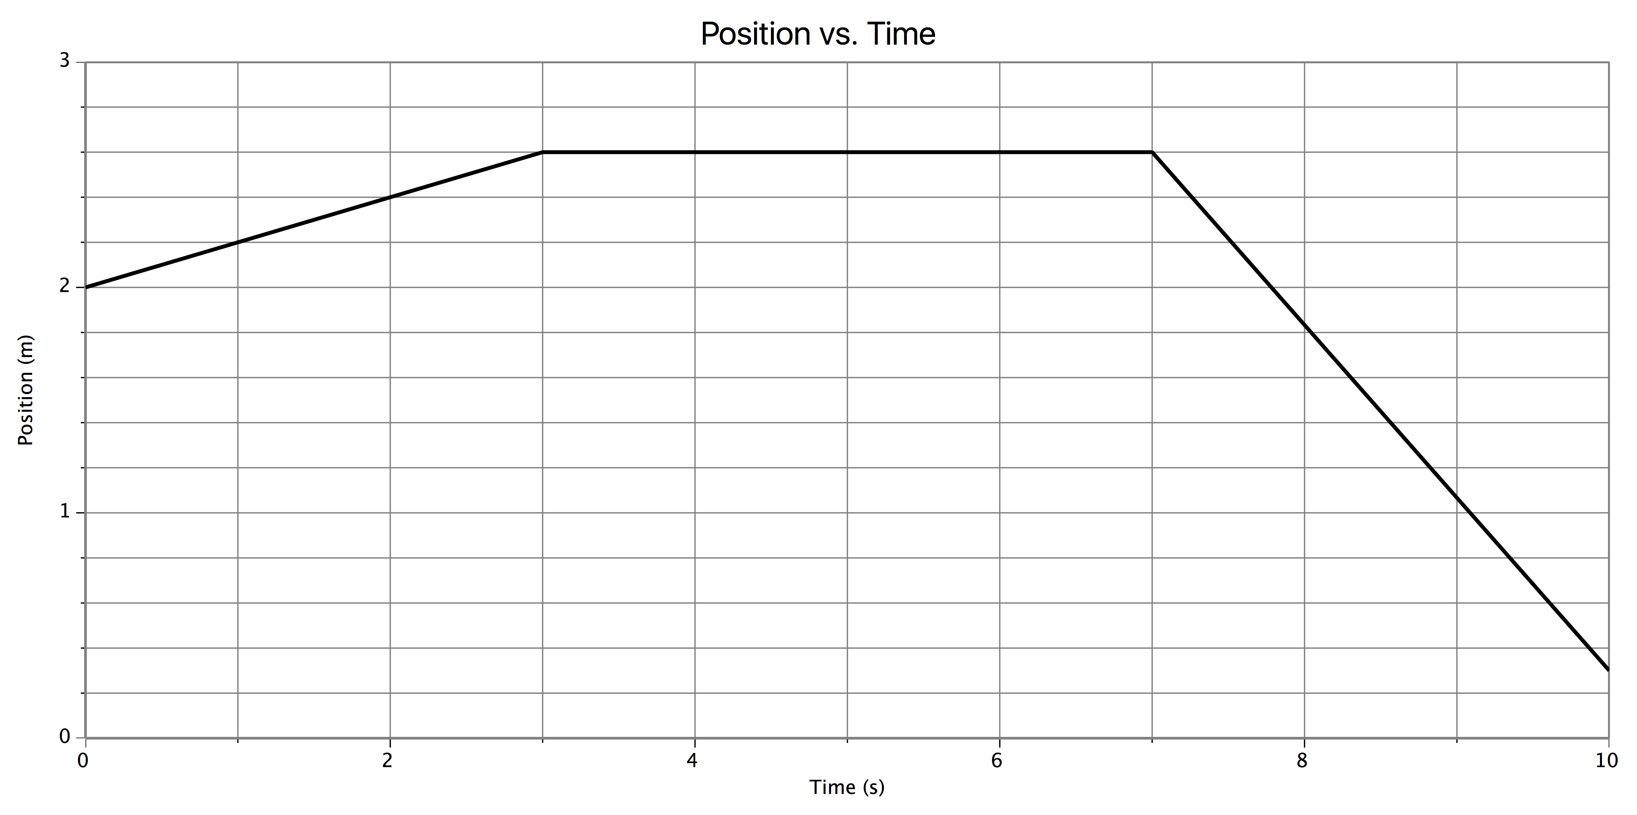
7. Written Description of Motion:

Motion Map:

0
+

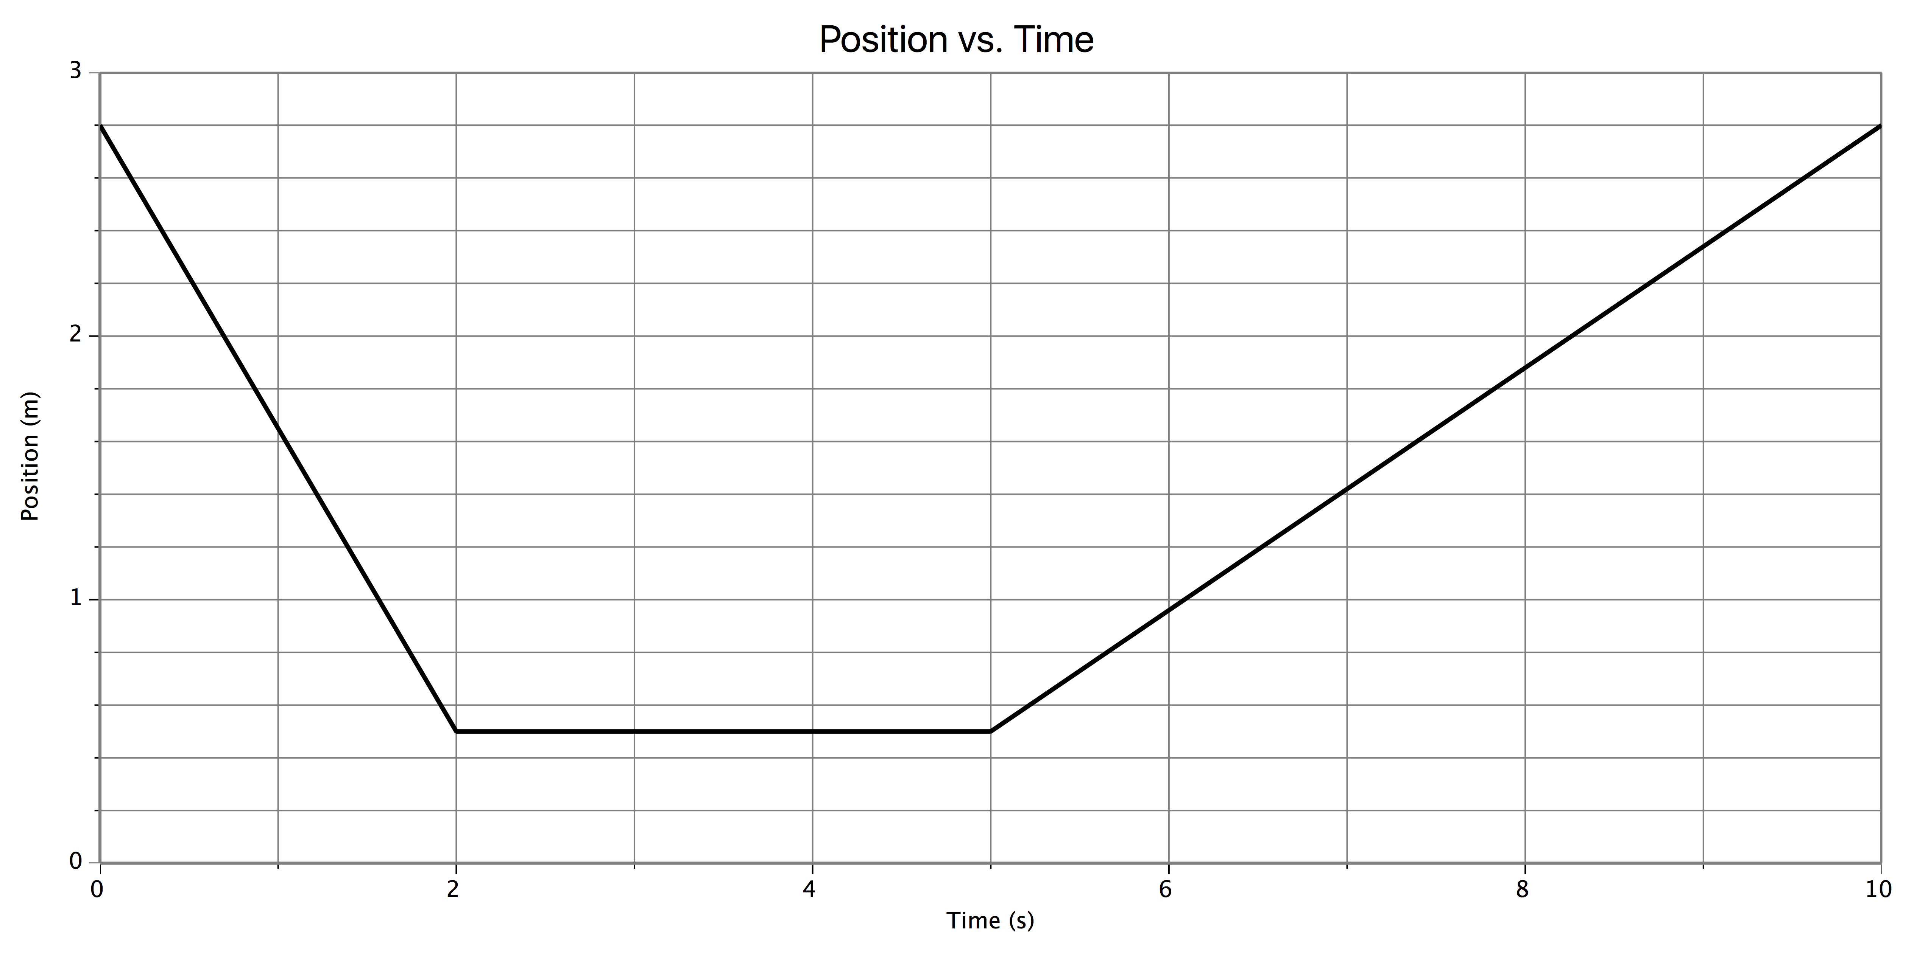
8. Written Description of Motion:

Motion Map:

0
+

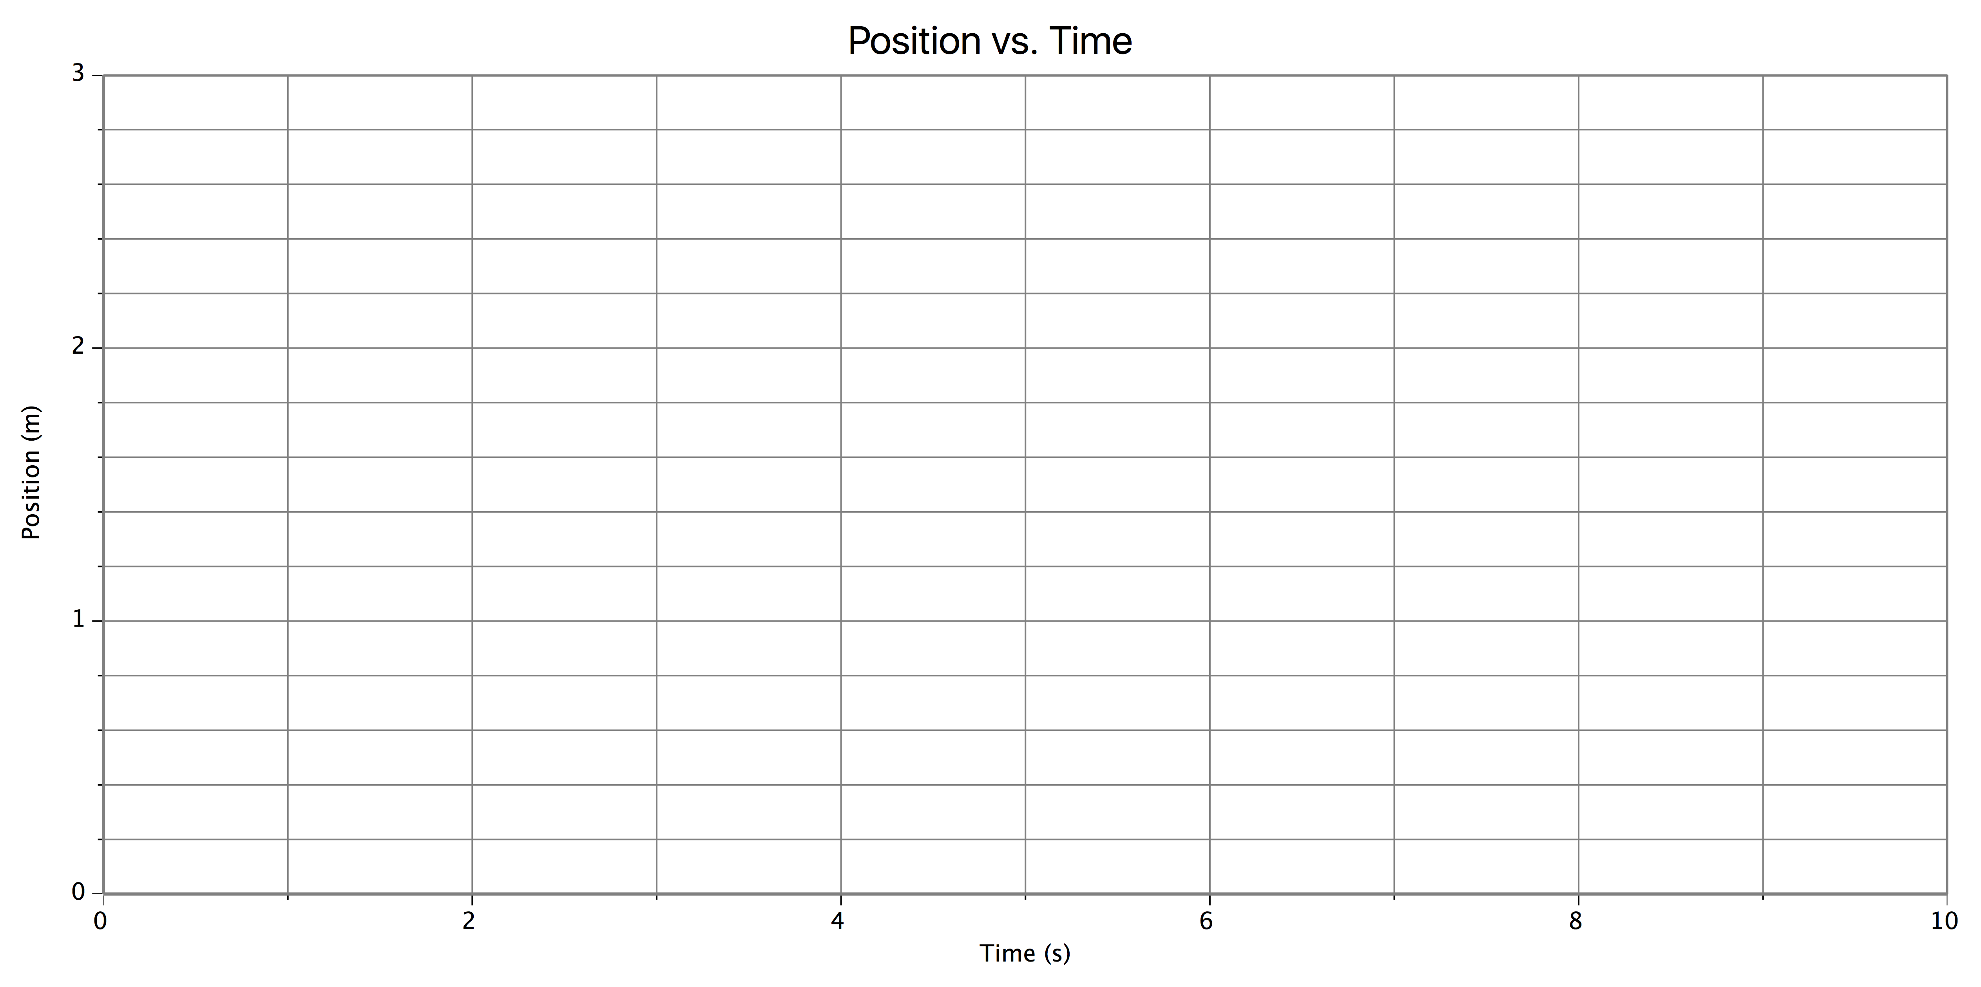
For the last situation, select the MATCH GRAPH option and try to reproduce the graph, or come up with your own motion to describe.
9. Written Description of Motion:

Motion Map:
0
+

